**Aim:-**

Introduction to Android, Introduction to Android Studio IDE, Application Fundamentals: Creating a Project, Android Components, Activities, Services, Content Providers, Broadcast Receivers, Interface overview, Creating Android Virtual device, USB debugging mode, Android Application Overview. Simple “Hello World” program.

**1) Select a new project.**

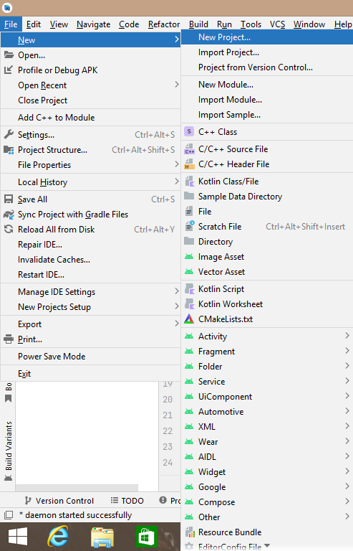

**2) Select Empty Activity.**

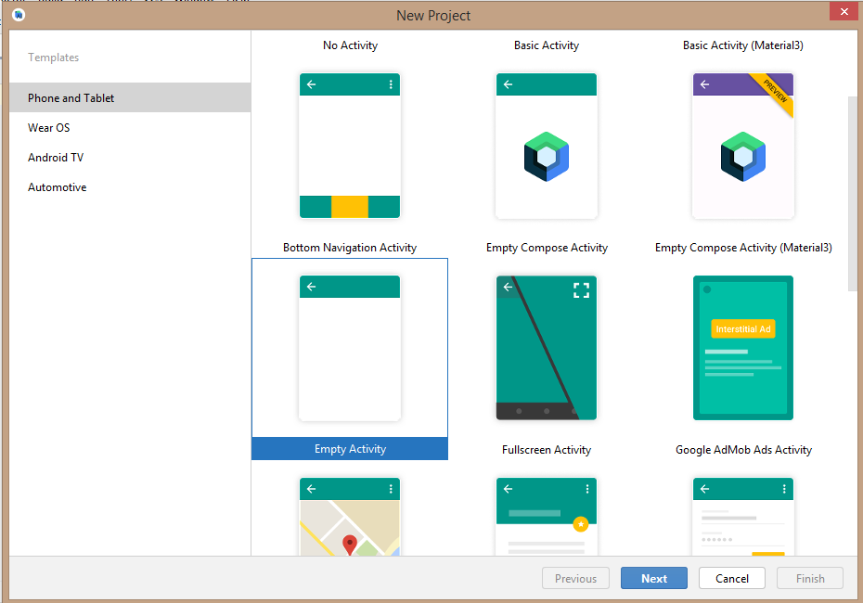

**3) Enter Project Name and Click On Finish.**

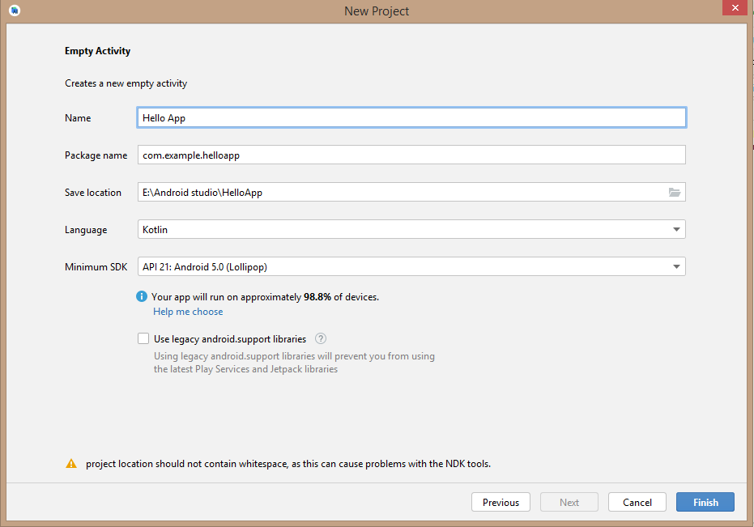

**Activity_main.xml –**

<?xml version="1.0" encoding="utf-8"?>

<androidx.constraintlayout.widget.ConstraintLayout xmlns:android="http://schemas.android.com/apk/res/android"

xmlns:app="http://schemas.android.com/apk/res-auto"

xmlns:tools="http://schemas.android.com/tools"

android:layout_width="match_parent"

android:layout_height="match_parent"

tools:context=".MainActivity">

<TextView

android:layout_width="wrap_content"

android:layout_height="wrap_content"

android:text="Hello World!"

android:textAlignment="center"

android:textColor="@color/black"

android:textSize="100sp"

app:layout_constraintBottom_toBottomOf="parent"

app:layout_constraintEnd_toEndOf="parent"

app:layout_constraintStart_toStartOf="parent"

app:layout_constraintTop_toTopOf="parent" />

</androidx.constraintlayout.widget.ConstraintLayout>

**Output –**

